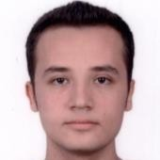 | Muhammed Behlül Uğur
Communication  +905511086405  uur.muhammed@gmail.com |  | Goals  I am looking forward to a challenging software development internship that allows me to contribute my foundation in computer programming, while further developing my skills in a professional and growing environment.
Skills  C++ (Intermediate)  C# (Beginner)  Python (Beginner)  UML |  | Education  Middle East Technical University – Computer Education and Instructional Technologies 3rd year - CGPA 2.92
Certificates  Object Oriented Design Coursera  Design Patterns Coursera  Software Architecture Coursera |  | Languages  - Turkish  - English
Social  Metu game development society  Metu radio society |  | Projects  - Developed a web-based agenda application using node.js.  - Developed a few of the popular old games in C++ using SDL2, and related libraries, and in Unity

References
Can be shown upon request.

